1. Construct a given class score following matrix A .

$A=\left[\begin{matrix}70 & 84 & 60 & 9 & 77 \\ 59 & 80 & 100 & 11 & 78 \\ 85 & 75 & 75 & 31 & 95 \\ 80 & 90 & 62 & 86 & 90 \\ 90 & 95 & 82 & 24 & 85 \\ 60 & 88 & 40 & 73 & 75\end{matrix}\right]$.

Use MATLAB to find the following:

1. Construct a matrix **B,** deleting **2nd and 4th row of A.**
2. Construct a matrix **C,** add a column with **4th row of A** to the **3rd row of B**.
3. Construct a variable **D,** calculate the average score of **matrix B**.
4. Construct a variable **E,** calculate the average score of **matrix A**.
5. Construct a variable **F,** classify scores individually into grades **.(A1 to F5)**
6. Construct a variable **G,** calculate how many people in each grades and each score average.
7. The function is given as:
$$y=3e^{0.25x}\cos\left(x-2\right)-1$$

8. Find the value for the function, for the interval of $0<x<10$, with step 0.1. (Use feval)
9. Find the minimum value for the function, for the interval of $0<x<10$, with step 0.1. (Use fminbnd)
10. Use ‘**fplot**’ to plot this function for the interval of $-10<x<10$. (Notes that: you must create a function handle for function $y$ and pass it to the command ‘**fplot**’)
11. The definition of the Legendre polynomial is as follow:

$P\left(n,x\right)=\frac{2n-1}{n}xP(n-1,x)-\frac{n-1}{n}p(n-2,x)$.

Where P(0,x) = 1, P(1,x) = x, X has a value between [-1, 1] with the step 0.004, n value is 10. When the value of m changes from 0 to 5, we can get five curves P0(x) ~ P5(x) as the figure 1.

1. Please draw these five curves on the same figure, remember to use the legend command to identify each curve.
2. Please get the graphic handle of P3(x), and use it to change the (i) color, (ii) linewidth, (iii) line type of P3(x).

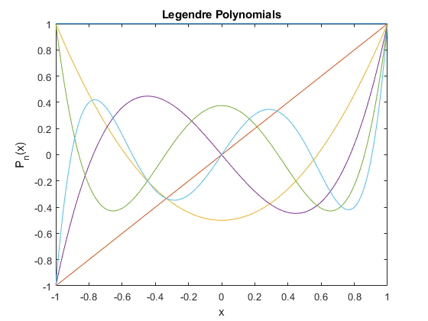

Fig 1.

1. Use the MATLAB command to draw a surface plot of the following functions:

${Z=ρ}^{2}2\sin{θ}\cos{θ}$, $ρ=\sqrt{x^{2}+y^{2}}$, $θ=\tan^{-1}{(\frac{y}{x})}$.

Where x is equally divided into 21 points between [-2, 2], and y is equally divided into 21 points between [-1, 1], so this surface has 21*21=441 points.

1. Use the given function to write a **MATLAB sub-function** to **Zernike.m**.
2. Use the ‘**meshgrid**’ command to build up a meshgrid in the x-y plane.
3. Plot the surface and the mesh of the z(x,y).
4. To rotate your surface plot at fix elevation angle at 180/12 degree, and variable azimuth angles between [-180, +180] with the step of 180/10.
5. Use matlab to slove the following differential equation

$$\frac{d^{3}y(t)}{{dt}^{3}}+12\frac{d^{2}y(t)}{{dt}^{2}}+36\frac{dy(t)}{dt}+16y(t)=14$$

use ode23, with initial condition

$$y\left(0\right)=0, y^{'}\left(0\right)=4, y^{''}\left(0\right)=-8$$

1. Write the equation as state variable equation.
2. Write the equation in (a) as the MATLAB function diff.
3. Use the function of (b) to solve the transient response of the variables in the equation using ODE23.